1. 
2. 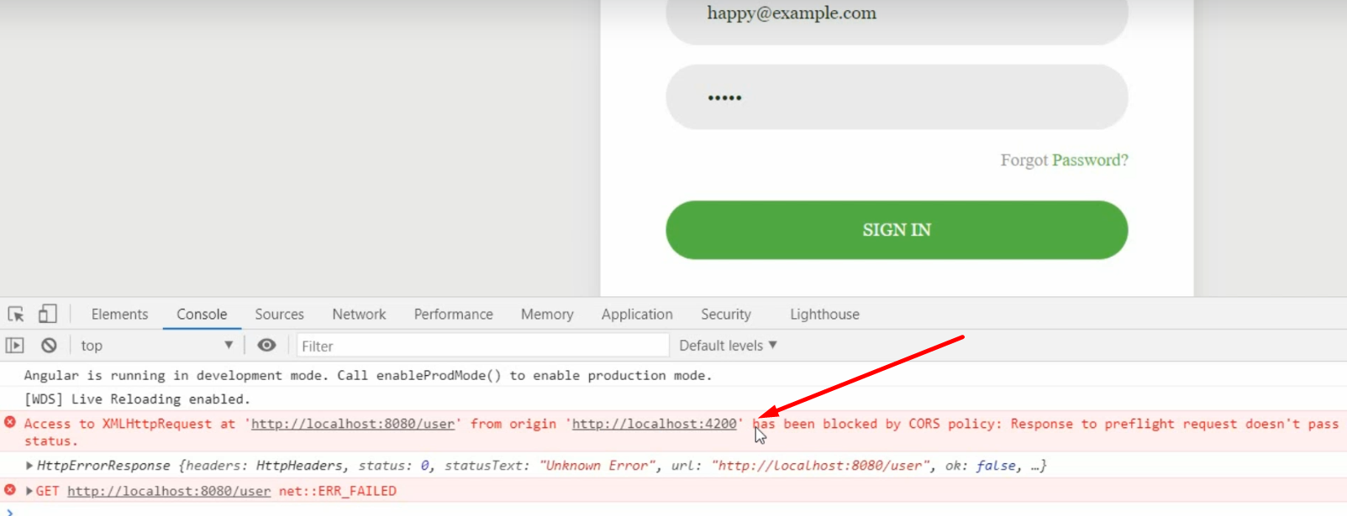
3. Credentials are right. Everything is right. Then what is wrong here?
4. Let’s see CORS in next lecture.